MURAMID ARTS AND CULTURAL CENTER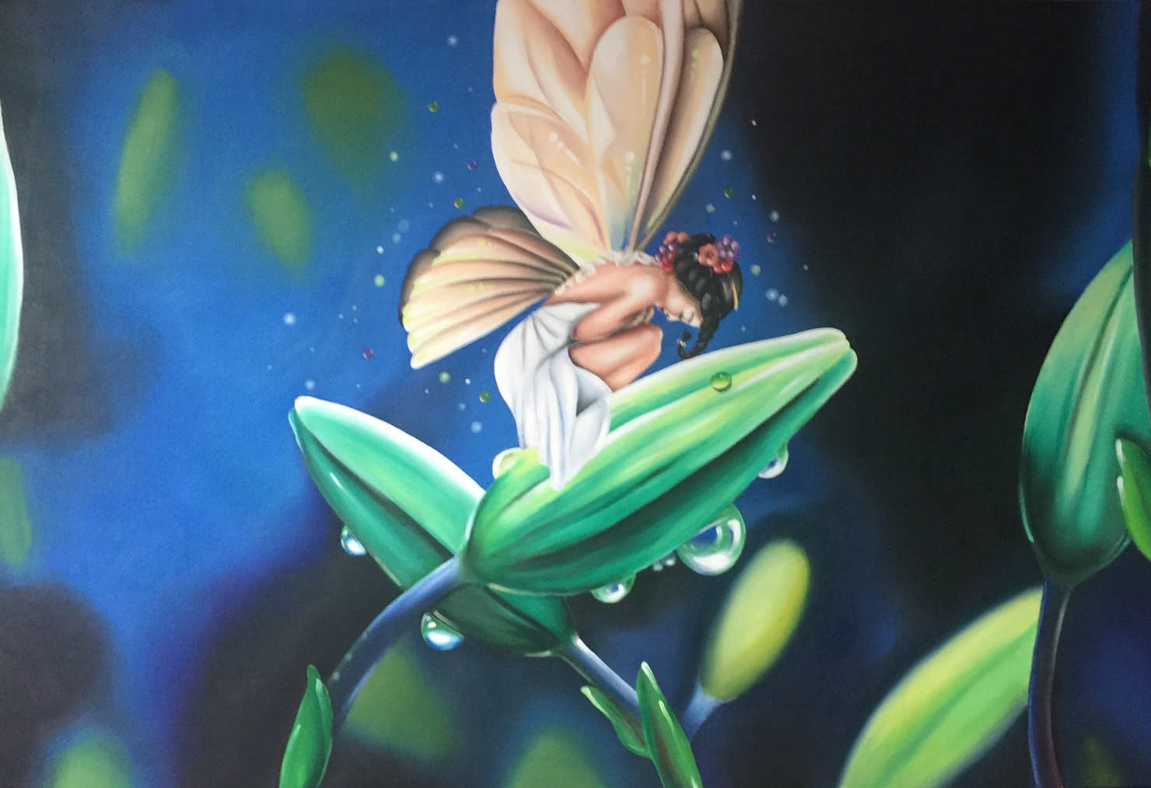
Art Miles Mural by Artist Weldon Mays

480 N. EL CAMINO REAL 92058
A Very Special Holiday Event
Celebrating A Cosmic Portal Opening and
“A Preview of What’s More in store for YOU in 2022”
December 12, 2021 – 1 – 7 pm
An Inspirational and Magical Afternoon and Evening with
Puppet Therapy Jams - Cosmic Gypsy Crafts Bazaar
Masked Character Appearances - Sound and Music Healing
Sunset Ceremony Drum and Music Circle
And an Enchanting Night Sky Star Spirit Ceremony
Introducing The Amazing Brazilian and Alaskan Puppeteers, Mask and Costume Designers Tresham, Bruna and Cynthia!
This is a FREE family event (donations always welcome) and a preview event for all to enjoy and experience magical unforgettable happenings during this holiday season!
Hosted by Joanne Tawfilis (PhD) and Mr. Aki Burkes

